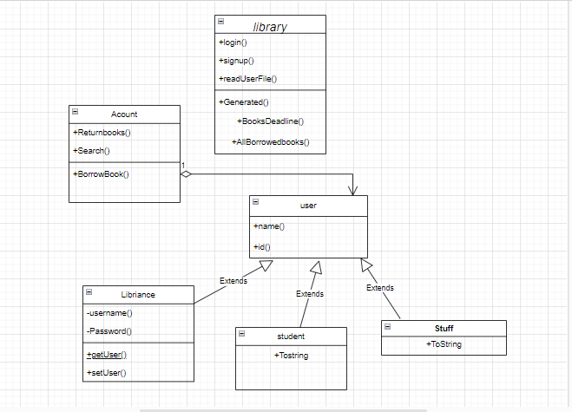
Library Class(Main):
The program starts by importing necessary packages such as File, FileNotFoundException, ArrayList, and Scanner. Then, it creates an ArrayList of Books and initializes files for Books, Students, Staff, and BorrowedBooks. An object of Librarians class is also created.

The program prompts the user to either log in or register as a new user. The user is then asked to specify whether they are a student, staff member, or librarian. If the user is a student, they can search for books by name, ISBN, or author. If the user is a staff member, they can search for students by name or ISBN, delete students, or add students. If the user is a new student, they can enter their name and a valid ISBN.
If the user is a librarian, they are prompted to either search for books or log out. If they choose to search for books, they can search by name, author, or ISBN.
The code includes several methods, such as searchForStudent(), searchForBook(), login(), deleteStudent(), and addStudents(). These methods perform various tasks such as searching for a student or book, logging in, deleting a student, and adding a student.

Student Class:
The Student class is a subclass of User class that contains methods for searching and logging in a student in the library system. This class utilizes ArrayLists and File input/output to store and access student information.

Methods:
Student() - default constructor.
Student(String name, String id) - parameterized constructor that takes name and id of a student as arguments and calls the constructor of the superclass to initialize them.
public static ArrayList<Student> searchForStudent(int n, File Student) - a method that searches for a student's name or ID in the library system. It takes two arguments, an integer n and a File Student. The integer n determines whether to search for a name or ID, and the File Student is the file containing student information. This method reads the file and stores each student's name and ID in separate ArrayLists. Then, it prompts the user to enter the name or ID they want to search for and compares it with the data in the ArrayLists. If a match is found, the method displays a message indicating that the name or ID is found. Otherwise, it displays a message indicating that the name or ID doesn't exist. Finally, the method returns an ArrayList containing all the students' information.
public void login(String k, File Student) - a method that logs in a student into the library system. It takes two arguments, a String k (which represents the student ID) and a File Student (which is the file containing student information). This method reads the file and searches for a line that contains the student's ID. If a match is found, the method displays the student's information. If not, it displays an error message.
This Student class provides methods for searching and logging in a student in the library system. It uses ArrayLists to store and access student information and File input/output to read and write data to a file. These methods are essential for the efficient functioning of the library system.

Staff Class:
The class has two constructors, the first one is empty and the second one takes two parameters, a name and an id, and passes them to the constructor of the superclass "User".

The first method, "addStudents", takes two parameters, an ArrayList of "Student" objects and a "File" object named "Students". It creates a FileWriter object with the name of the "Students" file and appends the name and ID of each student in the ArrayList to the file.

The second method, "deleteStudent", takes two parameters, a "File" object named "Students" and a String named "nameOfStudent". It reads the contents of the file and removes any line that contains the given student name.

The third method, "searchStaff", takes two parameters, an integer "n" and a "File" object named "Stuff". It creates three ArrayLists to store the names and IDs of the staff members and an ArrayList of "Staff" objects. It reads the contents of the "Stuff" file and populates the ArrayLists and the "Staff" objects with the data. It then prompts the user to enter a name or an ID to search for, and searches the ArrayLists for a match. If found, it prints a message indicating that the name or ID has been found; otherwise, it prints a message indicating that it hasn't been found.

The fourth method, "login", takes two parameters, a String named "k" and a "File" object named "Stuff". It reads the contents of the "Stuff" file and searches for a line that contains the given String "k". If found, it prints the line to the console.

Overall, the "Staff" class provides functionality for managing a list of students and searching for staff members in a given file.

Librarians Class:
Librarians, which contains various instance variables and methods for managing books, staff, and librarians. The class has a default constructor and a parameterized constructor that sets the userName and password instance variables.

The instance variables of the Librarians class are userName, password, nOfBorrowedBooks, nOfLostBooks, availableBooks, year, and month. The nOfBorrowedBooks and nOfLostBooks variables are integers, and the availableBooks variable is a boolean.

The class also contains an ArrayList called Books, which contains objects of the Book class. There are several getter and setter methods for accessing and modifying these instance variables.

The Librarians class has several methods for managing books, staff, and librarians. These include addBook, deleteBook, addStaffMember, deleteStuffMember, addLibrarians, and deleteLibrarians.

The addBook method writes book information to a file called Books.txt. The deleteBook method deletes a book from the Books.txt file. The addStaffMember method writes staff information to a file called Stuff.txt. The deleteStuffMember method deletes a staff member from the Stuff.txt file. The addLibrarians method writes librarian information to a file called librarians.txt. The deleteLibrarians method deletes a librarian from the librarians.txt file.
Borrow Class:
"Borrow" that extends the "Librarians" class. It contains several static methods and variables that allow a user to borrow a book from a library.

The "fine" method takes an ArrayList of books, a File object representing the borrowed book, and the current year and month as arguments. It calculates the difference between the current date and the borrowed date, and if the borrowed month and year match the current month and year, it prints a message saying there is no fine, otherwise, it prints a message saying the user will be fined $5.

The "addBorrowBook" method takes an ArrayList of books, a File object representing the borrowed book, and the borrowed date's month and year as arguments. It writes the book's details and the borrowed date to a text file, using a FileWriter.

The "borrowBook" method takes two File objects representing the books and the borrowed books, respectively. It reads the books file, creates an ArrayList of Book objects, and prompts the user to enter the name of the book they want to borrow. If the book is available for borrowing, it reduces the number of copies of the book by 1, adds the book to an ArrayList of borrowed books, calls the "fine" method to check if the book was returned on time and prints a message to the user accordingly. It also calls the "addBorrowBook" method to write the book's details and borrowed date to a text file. Finally, it returns the ArrayList of all the books in the library.
The code also uses several Java classes, including LocalDate, Date, Scanner, ArrayList, and File.

Book Class:
"Book" which has private instance variables for storing the name, author, ISBN, number of copies, category, and published day of a book. It also has an ArrayList of Book objects.
The class has a constructor that takes in the name, author, ISBN, category, number of copies, and published day of a book as parameters and initializes the corresponding instance variables.
Additionally, the class has setters and getters for all the private instance variables, and a toString() method that returns a string representation of the book object.
User Class:
This class defines a user object with a name and ID. The class also contains a static method called "searchForBook" that takes in two parameters, an integer "n" and a File object "Books", and returns an ArrayList of Book objects.
Inside the method, the code initializes several ArrayLists to store information about books, such as their names, authors, categories, ISBNs, and published days. It then reads data from a text file specified by the
"Books" parameter and creates a Book object for each line in the file. The Book objects are added to the ArrayList "arr", and the book information is also added to the corresponding ArrayLists mentioned earlier.
Next, the method prompts the user to enter a search option based on the value of "n". If "n" is 1, the user is asked to enter the name of a book and the method searches for the book's name in the "NamesOfBooks" ArrayList. If "n" is 2, the user is asked to enter the name of an author and the method searches for the author's name in the "NamesOfAuthors" ArrayList. If "n" is 3, the user is asked to enter an ISBN and the method searches for the ISBN in the "ISBN" ArrayList. Finally, if "n" is 4, the user is asked to enter the name of a book and its category, and the method searches for a book with that name and category by checking the corresponding ArrayLists.
If the book or author or ISBN or book name and category is found, a message is printed indicating that it was found. If not, a message is printed indicating that it was not found. The method then returns the ArrayList "arr" containing all Book objects read from the file.

